Czech University of Life Sciences Prague

Faculty of Economics and Management

Department of Information Technologies



Project documentation   
Web design

UniVerse News

Elchin Novruzov

The Quyet Nguyen

Anil Aksar

Ataberk Kuscu

© 2024

**Content**

1 Introduction 4

2 Implementation requirements 5

2.1 Pages 5

2.2 Header 9

2.3 Footer 9

2.4 Website Navigation 10

2.4.1 Main Page 10

2.4.2 Article Detail Page 10

2.4.3 Search Functionality 10

2.4.4 Authentication Options 10

2.4.5 Purcharse Membership 10

2.5 Technologies 11

3 Use of AI tools 12

4 Meet project requirements 13

4.1 Full-featured Website 13

4.2 All pages linked 13

4.3 Output runnable in a web browser, no need to install an application 13

4.4 Independent Pages 13

4.4.1 Full homepage 13

4.4.2 Category/Section 13

4.4.3 Article Detail 13

4.4.4 Search Results (+ search box on all pages) 13

4.4.5 Author profile 14

4.4.6 Purchase options 14

4.4.7 Unified Page for Sign In and Sign Up 14

4.5 Full Footer 14

4.6 Usability 14

4.6.1 Navigation 14

4.6.2 Breadcrumb Navigation 14

4.7 CSS code requirements 15

4.8 Responsive design 15

4.9 Semantic elements 18

4.10 Grid layout and Flexbox 18

4.11 Accessibility 18

# Introduction

The project is a prototype for a news website, demonstrating skills acquired from the Web Design course. **As agreed with the teacher during a seminar, the prototype will be fully developed using HTML and CSS.** The source code is hosted on GitHub at [**https://github.com/Elchin-Novruzov/Web-Design-project**](https://github.com/Elchin-Novruzov/Web-Design-project), and the live website can be accessed at [**https://elchin-novruzov.github.io/Web-Design-project**](https://elchin-novruzov.github.io/Web-Design-project)/.

Designed with a mobile-first approach, the website ensures seamless usability on both mobile and desktop devices, delivering an optimal experience for all users. The project showcases the basic functionality of a news site, including:

* A **index page** displaying the latest news.
* An **article page** showing news of the same category.
* An **article detail** page featuring the full content of an article.
* An **author profile** page providing information about the author.
* A **membership page** for purchasing subscriptions.
* A **search results page** displaying relevant articles.
* A **unified sign-in and sign-up page** for user authentication.
* A **404 error page** to notify users when a requested page is not found.

This prototype aims to illustrate the core features and usability of a fully functional news website.

# Implementation requirements

## Pages

The web project includes the following key pages:

* **Index Page**: Serves as the homepage, offering an overview of the site’s content.

* **Article Page**: Displays a list of articles of a category.

* **Article Detail Page**: Provides a detailed view of individual articles.

* **Unified Authentication Page**: Combines sign-in and registration functionality in a single interface for user convenience.

* **404 Error Page**: Custom-designed page to inform users when the requested content is not found.

* **Author Profile Page**: Showcases author biographies, articles, and other relevant details.

* **Search Results Page**: Displays content based on user search queries.

* **Subscription Page**: Facilitates the purchase and management of user subscriptions.

Most of the pages feature a unified header and footer for a consistent user experience.

## Header

The header includes:

* **Site Name**: Links directly to the main page for easy navigation.
* **Navigation Bar**: Allows users to browse different news categories.
* **Search Bar**: Enables users to quickly find relevant content.
* **Log In Button**: Provides access to the authentication page.

## Footer

The footer, present across all pages, includes:

* **Project Address**: Displays the official address of the site or organization.
* **Developer Credits**: Recognizes the team or individuals behind the project.
* **Navigation Bar**: Allows users to browse different news categories.

## Website Navigation

The website is designed for seamless navigation, ensuring users can easily explore and interact with its content.

### Main Page

* Displays the latest news from various categories.
* Users can click on an article to visit the Article Detail Page, where the full content of the article is available.

### Article Detail Page

* Features the full article content along with the author’s name displayed below the article title.
* Clicking on the author’s name redirects to the Author Profile Page, where users can learn more about the author, including their biography and other articles they’ve written.

### Search Functionality

* A search bar in the header allows users to enter keywords and find articles matching their interests.

### Authentication Options

* For users who are not logged in, a Sign In button is displayed next to the search bar in the header.
* Clicking the Sign In button redirects to the User Account Page, where users can either sign in or register for a new account.

### Purcharse Membership

* Many articles are accessible only to subscribed users. Unsubscribed users will see a label indicating "Only for Premium Members" on restricted articles. Clicking on this label redirects users to the Membership page, where they can purchase a subscription to gain full access.

## Technologies

For this project, the frontend will be developed exclusively using HTML and CSS. These technologies dominate the frontend landscape and are sufficient to demonstrate the skills acquired during the Web Design course.

# Use of AI tools

ChatGPT is utilized to generate basic HTML and CSS templates for project pages, providing an accurate and reliable starting point for code development based on described requirements. While it effectively creates foundational code, adjustments are often needed to fully align the output with specific project needs.

# Meet project requirements

## Full-featured Website

The project is a fully clickable, responsive website built with HTML and CSS.

## All pages linked

All pages are interconnected, ensuring users can navigate seamlessly using the provided links.

## Output runnable in a web browser, no need to install an application

The project is fully runnable in any web browser without the need for additional installations. Simply open the main page, index.html, in any browser to start using the website. The project is also accessible directly via the link: <https://elchin-novruzov.github.io/Web-Design-project/>.

## Independent Pages

### Full homepage

Displays the latest articles from various categories. Each article preview includes a photo and a title, meeting the requirement for a full homepage.

### Category/Section

Lists articles by category, accessible through the navigation menu in the header.

### Article Detail

Includes an introduction, photo, section/category labels, additional images in the article, links to similar articles, and space for user comments. Additional content (e.g., links to social media or supplementary info) is also present.

### Search Results (+ search box on all pages)

A search box is present on all pages, and the search results page includes demo content (not empty) to simulate functionality.

### Author profile

Offers detailed information about authors of articles.

### Purchase options

The **Membership page** displays various membership plans tailored to meet the needs of different users. Each plan includes details about the features and benefits available, allowing users to select the option that best suits their preferences.

### Unified Page for Sign In and Sign Up

A single page that allows users to both sign in to their accounts or sign up for new accounts, making it easier to access or create an account from the same interface.

## Full Footer

The footer includes:

* Project address
* Copyright details
* Developer credits

## Usability

### Navigation

The header includes a menu for category navigation, a search bar, and a Sign In button, ensuring users can easily access key sections of the website.

### Breadcrumb Navigation

Present on article and article detail pages to improve usability and help users understand the site structure.

## CSS code requirements

The CSS code for the project is stored in the main.css file. At the top of the file, color variables are defined using CSS custom properties (:root), making it easier to manage and refactor styles when the website needs to be redesigned or restyled.

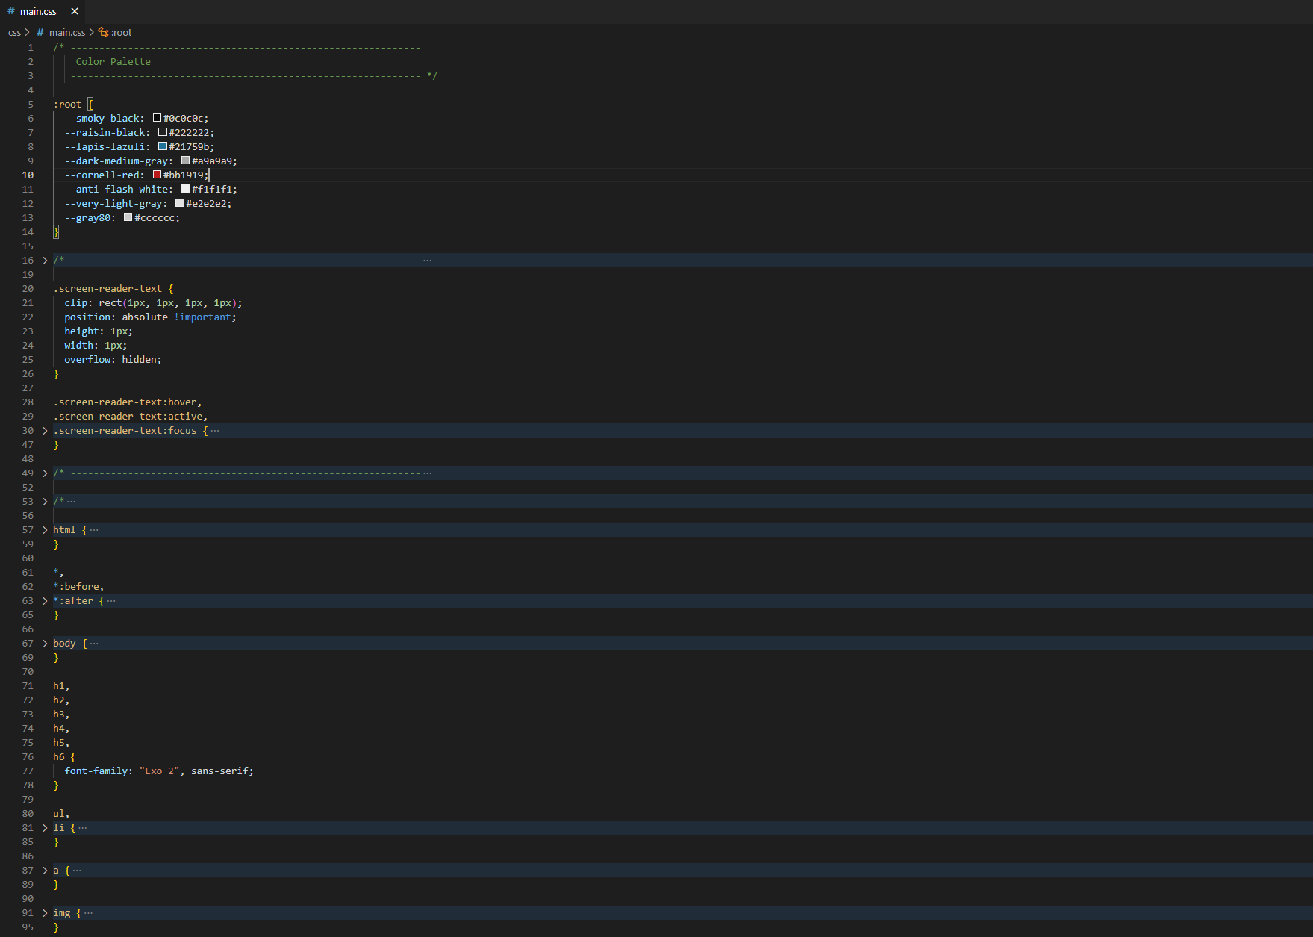

## Responsive design

All pages in the project are fully responsive, ensuring an optimal viewing experience across different devices.

|  |  |
| --- | --- |
| **Desktop** | **Mobile** |
|  |  |
|  |  |
|  |  |
|  |  |
|  |  |
|  |  |
|  |  |
|  |  |

## Semantic elements

The project incorporates following semantic HTML element:

* header: Used for the header on every page.
* nav: Used for the navigation bar within the header.
* section: Wraps the content of pages into distinct sections.
* article: Wraps the content on the article detail page.
* aside: Used for the sidebar on the article detail page.
* footer: Wraps the footer content on every page.

## Grid layout and Flexbox

The project uses CSS Grid layout extensively on the main page. In the **Breaking News** and **World** sections, one element spans multiple rows. The **More...** section at the bottom displays 8 articles in a grid layout.

Flexbox is used in layouts where elements can be organized in one-directional flow, such as in user-account and author-profile pages.

## Accessibility

All pages in the project have accessibility level AA.